|  |
| --- |
| University of toronto |
| Developing Instruments to Facilitate Endoscopic Ear Surgery |
| Thesis Progress Report |
| Institute for Biomaterials and Biomedical Engineering  Faculty of Applied Science and Engineering  University of Toronto  Centre for Image Guided Innovation and Therapeutic Intervention  The Hospital for Sick Children, Toronto |
|  |
| Arushri Swarup |
| Supervisor: Dr. Adrian Lewis James  Co-Supervisor: Dr. Jan Andrysek |
| 10/19/2017 |

|  |
| --- |
|  |

## 1. Introduction and Literature Review

## 1.1. Middle Ear Surgery:

Middle ear surgery is a type of ear surgery, or otological surgery, that is done to repair the ear drum (tympanoplasty), hearing bones (ossiculoplasty) and remove tumors (cholesteatoma) that grow within the middle ear and mastoid. Figure 1 shows pictures of middle ear anatomy discussed throughout this report. The images have been taken with a camera attached to an endoscope which has been inserted through the ear canal. This type of surgery is challenging as it requires precise, microscopic movements within a very confined volume in a highly sensitive region due to the presence of the facial nerve.

### 1.1.1. Microscopic vs. Endoscopic Ear Surgery:

Traditionally, the middle ear space is accessed by cutting away tissue through a postauricular incision, as shown in Panel 1 of Figure 1; a microscope is then used to visualize the surgical field. This is an invasive method of surgery, resulting in a scar and longer hospital stay [1]. A new approach to ear surgery involves inserting an endoscope through the ear canal, a natural orifice, to provide direct access and a wide angle view into the middle ear. Using an endoscope reduces the time required to gain access, drill bone for exposure and close during middle ear surgery and enables visualization of hidden recesses within the middle ear, including the sinus tympani, anterior and posterior epitympanum and hypotympanum [2][3][4][5]. As well, the endoscope allows visualization past the shaft of the instrument, such as the drill, which is a problem during microscopic surgery [6]. Panel 3 A and B in Figure 1 show the difference in operating room setup when using the microscope versus the endoscope. Panel 3 C and D in Figure 1 show the difference in field of view between the microscope and endoscope.

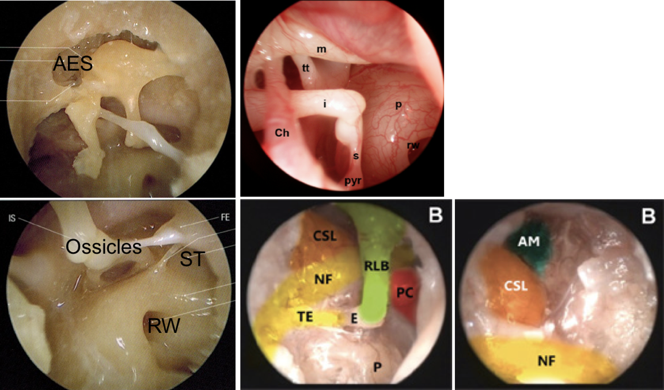

Figure 1: These are endoscopic images through the ear canal during a dissection of the middle ear. I, incus; m, malleus; s, stapes (the ossicles); p, promontory; ch, chorda tympani; rw, round window niche; AES, anterior epitympanic space; ST, sinus tympani; NF, facial nerve, CSL, lateral semi-circular canal and entry into the mastoid antrum; AM, entry to the mastoid antrum [32] [33] [34].

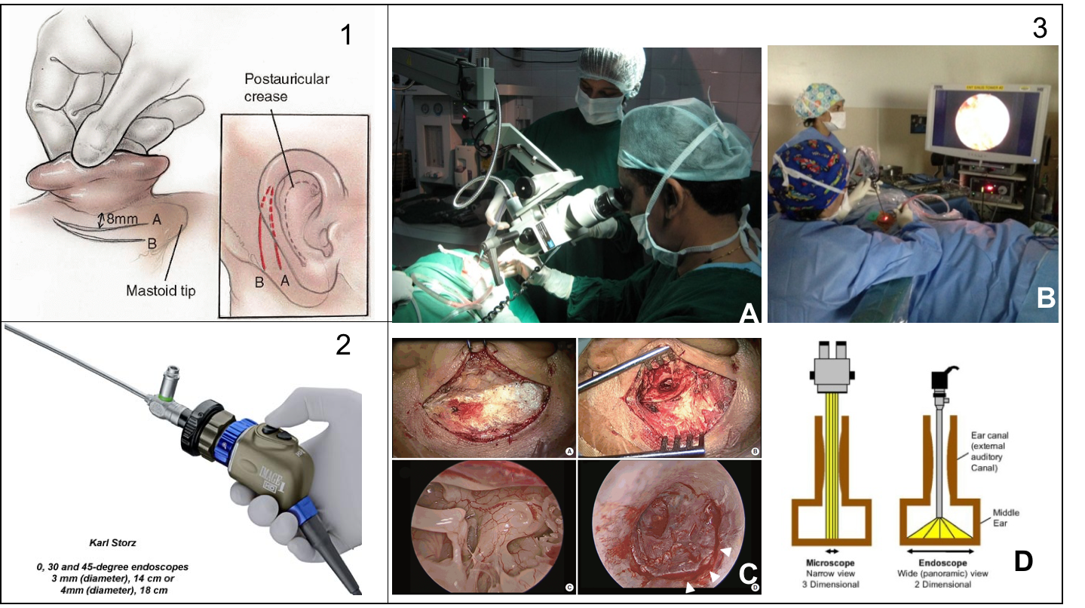

Figure 2: Panel 1 shows the slits made to access the middle ear for invasive microscopic ear surgery [7]. Panel 2 shows an endoscope that is attached to a high definition camera, which is used to visualize the surgical field during endoscopic ear surgery [8]. Panel 3: The top two images (A&B) show the difference between the operating room setup for microscopic ear surgery and endoscopic ear surgery [9], [10]. The bottom two images (C&D) show the difference in view between microscopic and endoscopic approaches. C is from Choi et al. who show the difference in view between microscopic (top two squares of C) and endoscopic ear surgery (bottom two squares of C). The figure on the right shows the difference in field of view between the microscope (left of square D) and endoscope (right of square D) [11], [12].

Despite reducing invasiveness and patient hospital stay and increasing visualization and direct access of the middle ear, endoscopic ear surgery has a low adoption rate [1][13][14].  The principal challenge with totally transcanal endoscopic ear surgery (TEES) is that a one-handed surgical technique is required as the endoscope is held in the other hand[13][10]. During traditional surgery, the non-dominant hand usually maintains suction and removes blood from the operative field while the dominant hand performs the delicate maneuvers [10]. Otologic instruments were developed for two-handed microscope-guided surgery so they are not optimized for the TEES environment. These challenges are particularly evident during two procedures: cholesteatoma removal and tympanoplasty.

### 1.1.2. Cholesteatoma Removal and Tympanoplasty

Two particularly challenging procedures for TEES are cholesteatoma removal and tympanoplasty. Cholesteatoma is an abnormal skin growth that occurs behind the ear drum (tympanic membrane) inside the middle ear and its growth can damage the ossicles and/or facial nerve and cause temporary or permanent hearing loss. TEES to remove cholesteatoma is challenging because the tumors are usually located in areas that are visible through the endoscope but inaccessible via current rigid tools, thus requiring the surgeon to drill bone to gain access. Tympanoplasty is the reconstruction of a perforated ear drum, by placing a synthetic (animal-derived) or cartilage graft on it. It is challenging to maneuver and position the graft using TEES and requires training, experience and resources [15]. As these are challenging procedures, they will be the focus of this research for evaluating new instrumentation to improve TEES.

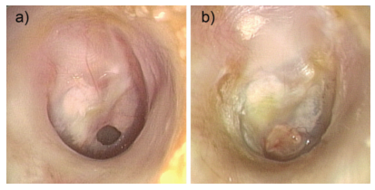

**Figure 2:** These images, taken from James et al., are endoscopic photographs. (A) shows a perforated ear drum and (b) shows the postoperative result, 2 months after tympanoplasty surgery that used a cartilage graft [15].

As otologists have been trained and gained experience in microscope-guided ear surgery, they have developed techniques with the according instruments and have become accustomed to a two-handed surgical approach. By learning different surgical techniques and gaining experience with the endoscope, most surgeons find that they can complete more cases totally endoscopically [16][13][2][10]. TEES reduces the invasiveness of ear surgery, however as it is a relatively new technique, there is room for further development of current TEES-specific instruments that are discussed next [4].

## 1.2. TEES Instrumentation:

Figure 2 shows different sets of TEES instruments, many of which are presented by Badr-El-Dine et al. [4]. Only one instrument is used at a time and the ear canal restricts the movement of instruments thus many have curved tips in order to reach structures. The Spiggle & Theis Panetti set incorporates suction along the shaft of its instruments in order to allow for two functionalities: suction and dissection or suction and cutting. Having dual functionality in one tool eliminates the need to switch between a suction instrument and dissection instrument or knife [17]. Grace Medical and Karl Storz have similar suction capabilities [18][19]. The Thomassin dissector, Derlacki Mobilizer and Rosen Needle are frequently used by the PI, an experienced TEES surgeon, to position grafts and dissect tissue as their respective tip shapes are preferred to manipulate tissue effectively. The Rosen Needle tip curvature allows for dissecting tissue that is attached to the ear drum as the tip shape complements the curvature of the ear drum. Also, when the Rosen needle is rotated axially, the tip follows a trajectory which is useful to manipulate tissue without having to translate the tool which would cause the instrument shaft to collide with the endoscope or ear canal wall. These are handheld instruments designed specifically for TEES; recently, there has been research and development of robotic minimally invasive techniques to access the middle ear, discussed below.

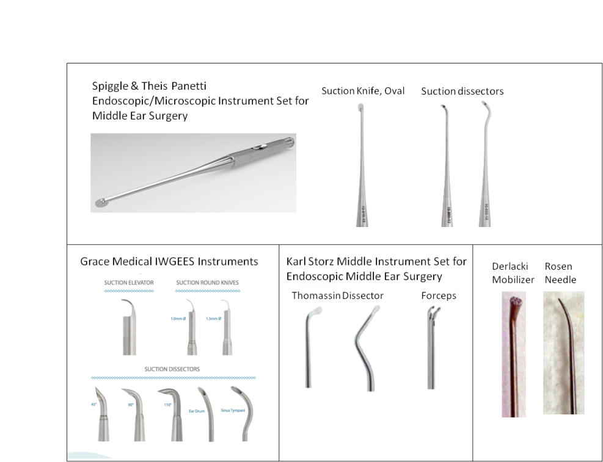

Figure 3: Current instruments used during TEES.

## 1.3. Approaches to minimally invasively access the middle ear

Yasin et al. present a robotic tool that aims to allow middle ear surgeons to perform precise tasks and access hard to reach anatomical targets using a custom-designed robot that controls grippers attached to a shape-set nitinol tube with a fixed radius of curvature of 7.5mm at the tip, see Figure 3 [20]. The nitinol ‘cannula’ can be retracted into a straight stainless steel ‘stem’ and when the tool needs to reach something, the cannula extends out of the stem to curve out and reach the target.

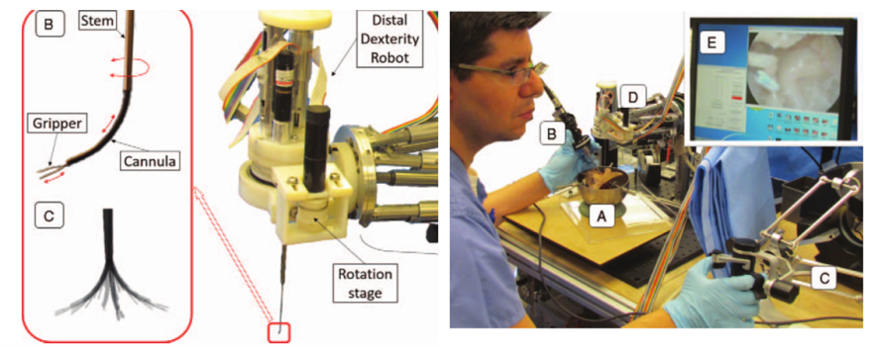

Figure 4: Yasin et al. developed a steerable robot-assisted micromanipulation device for the middle ear. The left panel shows the robot with the tool extending downward out of it, and the right panel shows the surgeon teleoperating by gripping the ‘distal dexterity robot’ [20].

Fichera et al. presented a miniature robotic endoscope that is able to pass through the Eustachian tube and visualize the middle ear using a bendable tip that uses a robotic wrist mechanism [21]. This group used patient CT scans rendered into 3D computer models to plan the path for the instrument to take to reach the middle ear through the Eustachian tube and optimized the geometry of the wrist to complement this path. The endoscope tip was able to visualize the sinus tympani when inserted in a phantom model, which is a hard-to-access region within the middle ear. This tool is designed to be a minimally invasive diagnostic tool for middle ear diseases by eliminating the need to cut and lift the ear drum to visualize internal ear structures; it provides inspiration for the design of a similar tool for TEES.

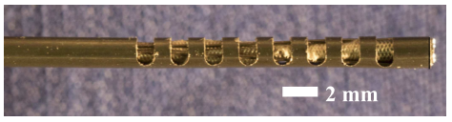

Figure 5: Steerable endoscope to visualize the middle ear. 8 notches in a Nitinol Tube of inner diameter 1.60mm and outer diameter 1.80mm allow the tip to bend by pulling on a cable attached to the most distal cutout (right hand side of the tube). An HD chip-tip camera and fibre-optic light sources are located at the leftmost end of the tube [21].

The principal investigator of this project is an otologist with 12 years of TEES experience. Through observation of his TEES surgeries, it was concluded that the PI commonly uses the Panetti set, Thomassin Dissector and Rosen Needle, see Figure 3, because the tip curvature and shape are appropriate to dissect and manipulate tissue. The Panetti set has the added benefit of suction which eliminates the need to switch between dissectors and suction instruments. However, the PI has expressed that rigid curved and straight instruments are unable to reach around corners within the middle ear space, where cholesteatoma is visualized by the endoscope. This requires the surgeon to remove bone from the patient. This could likely be avoided if the surgeon was able to control the curvature of the instrument tip, enabling access to dissect cholesteatoma.

Very recently, new technologies that increase instrument dexterity and range of motion within small workspaces have been applied to TEES (refer to Figure 3 and Figure 4). These technologies are reviewed as potential solutions to address this challenge but also have limitations. The tip of the robotic tool developed by Yasin et al. enables control of the tip’s arc length however, the radius of curvature is still rigid at 7.5mm, and may not be able to reach all hard-to-reach areas within the middle ear, similar to current tools. The robotic tool developed by Fichera et al. is able to control the radius of curvature to access hard-to-reach areas but its purpose is visualization and performing a surgical procedure would require the insertion of another instrument with a tip that is stiff enough to perform dissection and manipulation of structures. As well, the instrument geometry is designed to enter through the Eustachian tube, not the ear canal. The robotic tools presented are not yet available commercially and would be very expensive to implement for TEES; a manual, handheld tool with a similar articulating tip may be more appropriate and cost-efficient. These tools provide motivation to develop a new instrument that can alter its arc length and/or radius of curvature to access and dissect within the hard-to-reach areas. This describes a specific tool type that may facilitate TEES; it is important to have an understanding of the needs of surgeons performing TEES in order to design and develop tools that would facilitate the technique. This can be done by conducting a needs analysis study.

## 1.4. Needs Analysis

In order to advance the development of TEES technology and instruments to facilitate the technique, it is important to have a detailed understanding of the limitations of current instruments and the specific challenges that surgeons face. Surveys and questionnaires are used to gain information regarding a specific topic by consulting a wide variety of experts in the field. Marcus et al. assessed the technical challenges of endoscopic neurosurgery and the scope for technological advances that would overcome the challenges by surveying members of the Society of British Neurosurgeons [22]. As well, the members of the Canadian Society of Otolaryngology were surveyed about the current status of endoscopic ear surgery in Canada and reported a generally positive attitude toward endoscopes (81%) and their potential in the future of ear surgery [13]. Therefore, this method has been used to gain knowledge in the field of endoscopic surgery and will be used in a needs analysis study to determine which TEES challenges need better instrumentation.

# 2. Objectives/Hypotheses

This project aims to design, fabricate and evaluate new instrumentation that would address the challenges faced by endoscopic ear surgeons. To do this, the project is composed of two phases: phase one is a needs analysis study which surveyed experienced otologists about instruments they would like to be developed and phase two is developing and testing a prototype instrument to address the needs of surgeons.

## Phase 1: Understanding the Needs of Endoscopic Ear Surgeons

I hypothesize that otologists need better instrumentation to address specific challenges posed by TEES. Further, I hypothesize that the need for better instrumentation will be affected by the degree of TEES experience and the use of TEES-specific instrument sets. A mixed-methods study was conducted to explore these hypotheses.

## Phase 2: Prototype Development

Based on input from the needs analysis study, I hypothesize that an instrument with a steerable tip can reach areas visualized by the endoscope that current tools cannot. Furthermore, I hypothesize that adding functionalities to a steerable tip such as suction, laser fibre orientation or dissection will be beneficial for surgeons performing TEES.

# 3. Methods

## Phase 1: Needs Analysis Study

Please refer to the attached paper, to be submitted to the Otology and Neurotology journal within the next month, entitled “The Current Limitations and Future Direction of Instrument Design for Totally Endoscopic Ear Surgery: A Needs Analysis Survey.”

## Phase 2: Developing an Instrument for TEES

## 3.1. Instrument Design

From the needs analysis, it was determined that the challenge that exhibits the greatest need for better instruments is “reaching structures visualized by the endoscope”. From the study, the use of a TEES instrument set did not significantly affect this need, thus it can be inferred that current TEES instruments are not enabling enough reach. An instrument with a tip that can assume varying levels of curvature through the surgeon’s control while in the operating field was designed, prototyped and is undergoing validation testing to address this need. Table 1 outlines the design requirements of the instrument, against which the prototype(s) will be validated.

The instrument’s design can be broken down into two components: the tip and the handle. The instrument tip consists of a compliant joint (or wrist) fabricated from a nitinol tube, <2mm in diameter. The tip is articulated by pulling on a cable anchored at the tip and a finger piece on the handle. The instrument aims to satisfy four objectives: reaching, suction, orientation of a laser fibre and dissection. In order to enable reach, the curvature can be defined by two variables: radius of curvature and arc length. The range of these were determined by using patient CT scans to understand the appropriate curvature to reach patient anatomy. After this, the suction instrument, laser fibre instrument and dissection-enabled instrument tip were prototyped. Lastly, the ability to reach structures was tested using an endoscope and 3D printed anatomical models.

**Table 1:** *Design Requirements Table*

|  |  |  |  |  |
| --- | --- | --- | --- | --- |
| **Requirements:** | **Description:** | **Metric:** | **Prototype 1** | **Prototype 2** |
| **Functional Requirements:** | | | | |
| Reach areas visualized by the endoscope | The tool tip can touch/access the areas within the middle ear that are visualized by the endoscope. | Number of target areas touched/accessed |  |  |
| Reach hard-to-reach areas such as the sinus tympani, boundaries of the antrum | The tool tip can touch/access the sinus tympani and boundaries of the antrum. These are areas identified as hard-to-reach by the PI | Sinus Tympani: PASS/FAIL  Antrum boundary: PASS/FAIL |  |  |
| Tip stiffness | The tool tip can withstand forces applied at the tip by bony structures and soft tissue | Force required to break tip (N) |  |  |
| Tip can dissect tissue | The tool tip is able to handle, manipulate and/or maneuvre soft tissue in order to perform surgical tasks. | The tip can dissect mock cholesteatoma, fabricated out of silicone. PASS/FAIL |  |  |
| Suction | The suction power is comparable to the 19-gauge sucker and/or Panetti instruments. | Flow rate |  |  |
| **User Requirements:** | | | | |
| Easy to control (grip and ergonomics of handle) | The surgeon can control the tool easily. | Surgeon feedback (Likert scale rating) |  |  |
| Easy to use (grip and ergonomics of handle) | The surgeon can easily use the tool to perform its functionality (tip bending, suction, laser fibre orientation, etc.) | Surgeon feedback (Likert scale rating) |  |  |
| Feels like an existing tool | The tool feels like the current tools used by the surgeon such that they do not have to learn how to use a completely new tool design. | Surgeon feedback (Likert scale rating) |  |  |
| **Constraints:** | | | | |
| Fit alongside the endoscope | The tool shaft can move within the ear canal without being constricted by the endoscope. | Surgeon feedback (Likert scale rating) |  |  |
| Fit inside the ear canal | The tool shaft can fit inside the ear canal and can move easily, with enough clearance. | Surgeon feedback (Likert scale rating) |  |  |
| Sterilizability | The tool can be sterilized as per hospital standards so it can be used in patient. | PASS/FAIL |  |  |

## 3.1.1. Steerable Instrument Tip Design

The requirements of the instrument tip are: ability to reach and dissect structures and tissues, maintain stiffness, suction and be easy to control. The instrument tip was designed to be flexible and controllable by a simple mechanism at the handle. A single degree of freedom compliant joint design fabricated from a nitinol metal tube was selected so that it would be easy to control, requiring minimal effort by the surgeon, able to suction and maintain stiffness due to the metallic properties.

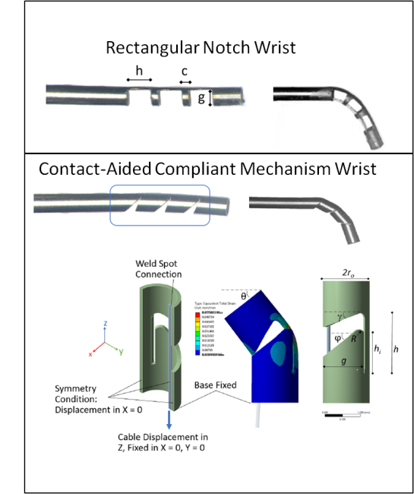The CIGITI lab develops notched tube compliant joints which define the underlying mechanism of the controllable flexible tip, see Figure 6. It is a single degree of freedom compliant joint with notches cut into a nitinol tube. Nitinol is a superelastic material that is used for this application as the material properties allow it to bend into a curve and return elastically to its original shape, i.e. with no plastic deformation of the tube [insert citation]. Notches in the tube allow the wrist to have greater flexibility and the notch geometry can be customized to achieve the desired arc length and radius of curvature. The controllable flexible instruments presented here have a rectangular notch geometry and a compliant contact aided mechanism (CCM) geometry. The paper presenting these wrists “Design of a Contact-Aided Compliant Notched-Tube Joint for Surgical Manipulation in Confined Workspaces” was co-authored by myself and is to be published in the ASME Journal of Mechanisms and Robotics.

The rectangular notches are machined in the CIGITI lab by myself using a micromilling machine. The CCM notches are laser cut and increase the strength of the wrist, while achieving the same bending angle compared to the rectangular wrist [insert citation]. The CCM wrist is beneficial for TEES as it enables a stronger, stiffer tip that would not break as easily and be able to handle/dissect tissue without being flimsy.

**Figure 7:** Eastwood et al. describes the two wrists that are presented in this report. The top panel shows the simple, rectangular notched wrist geometry. This is the geometry used for manufacturing prototype 1. The bottom panel shows the contact-aided compliant notched tube, which was laser cut into a nitinol tube to manufacture prototype 2. A cable is attached at the ‘weld spot connection’ and pulling on the cable (downward as shown in the image) causes the joint to bend.

## 3.1.2. Steerable Instrument Handle Design:

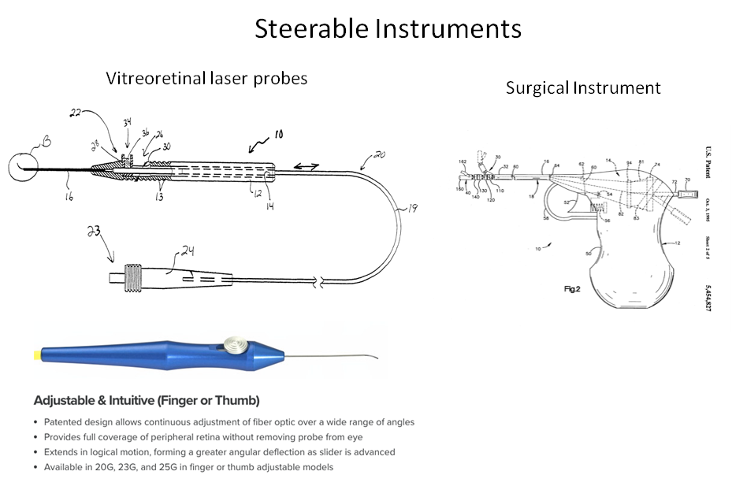 After observing the PI perform multiple TEES cases and interviewing the PI and his colleagues at the 2016 Endoscopic Ear Surgery Course in Toronto, it was determined that the instrument’s handle should allow the surgeon to maintain the same grip as with existing instruments for ease of use. The goal of the new TEES instrument would be to help the surgeon perform TEES rather than introduce a new challenge of learning how to maneuver and manipulate a new instrument. There are many steerable instruments on the market, two of which are shown in Figure 7. These are instruments where the handle design would be suitable for the new TEES instrument and both types were prototyped, but the PI preferred the feel, form and function of the handle similar to the vitreoretinal laser probes, shown in Figure 7, as the grip to handle this instrument is synonymous to current instruments and would require little added effort to control the tip.

Figure 8: These are two examples of current instruments that are steerable. The vitreoretinal laser probes are used to deliver laser energy to the retina for therapy. The slider at the handle allows the surgeon to push out the pre-shaped 90o nitinol tip. The surgical instrument is a manually engageable handle + steerable tip with pin joints [23], [24].

## 3.1.3. Instrument Development:

The instrument prototype will aim to satisfy four objectives: 1) reaching structures visualized by the endoscope, 2) suction blood and fluid, 3) orient a laser fibre and 4) dissect tissue. The first objective is the primary objective as it is the surgical challenge that exhibits the greatest need for better instruments by TEES surgeons. Suctioning blood and fluid while performing another function (i.e. reaching, and dissecting) mimics the Panetti instrument set, which is preferred by experienced TEES surgeons [4]. A laser fibre is used to ablate tissues where cholesteatoma was residing in order to ensure it does not recur by burning any residual cholesteatoma cells [25]. The laser fibre is straight; in order to ablate tissue in the hard-to-reach areas where cholesteatoma resides, the laser fibre tip could be oriented into the appropriate bending angle. Lastly, dissecting tissue is a common surgical functionality; a tip geometry that could manipulate tissue would achieve this objective. Designing for the first objective is discussed next.

## 3.1.3.1. Objective 1: Reaching Structures Visualized by the Endoscope – Instrument Tip and Handle Design

The tip’s compliant joint (or wrist) mechanism aims to satisfy the primary objective of reaching structures visualized by the endoscope. The wrist was manufactured using a nitinol tube, outer diameter (OD) = 1.24mm, inner diameter (ID) = 1.03mm. In order to select the OD of the nitinol tube, the average diameter of the ear canal was considered. Ito et al. measured the diameter of the ear canal in 31 pediatric patients with narrow ear canals; it can be proposed that a tool that can be used inside the narrow ear canal of a pediatric patient can also be used in adult sized ear canals [26]. All patients successfully underwent TEES and the smallest anterior-posterior diameter ranged from 3.2 to 7.1 mm (mean: 5.0 ± 1.0 mm) and the smallest superior–inferior diameters ranged from 3.4 to 10.3 mm (mean: 5.9 ± 1.3 mm) [26]. The endoscope diameter is 2.7mm, so in order to fit inside the ear canal and have space to maneuver, a maximum diameter of 2mm was set. The minimum ID was set based on suction capability; the ID of a 19 gauge sucker was chosen as a reference as it is the smallest diameter sucker used for TEES by the PI.

The nitinol notched tube was laser cut in the CCM pattern by Pulse Systems, USA. Refer to Figure 8 for a picture of the instrument. The nitinol wrist was soldered to a stainless steel shaft that is clamped in a collet, using a collet clamp, at the distal end (tip end) of the handle. The handle was machined so the collet clamp could be threaded onto the distal end with enough room for the finger piece to rotate. The cable, soldered to the tip of the wrist, runs along the tube and is secured with a set screw inside the finger piece.

**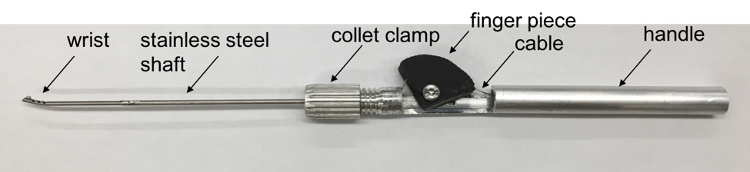****Figure 9:** Controllable flexible instrument: reaching prototype. The wrist consists of CCM notches laser cut into a nitinol tube, connected to a stainless steel shaft that is clamped onto the handle that consists of a finger piece that controls the cable displacement of the cable attached to the nitinol wrist. Moving the finger piece back causes cable displacement and thus wrist actuation.

To finalize the design of the compliant joint such that it will reach the areas of interest within the middle ear during TEES, a simple experiment was conducted to find the appropriate range for radius of curvature and arc length. Fichera et al. described the process used to create the robotic steerable endoscope, refer to Figure 5 [21]. In order to determine the appropriate curvature of the wrist, 3D models of patient middle ear space were generated by CT scan image segmentation. On these models, target points for the endoscope were identified and the optimal paths to reach the target points was computed using a computer software developed by the research group. These paths maximized visual coverage of the sinus tympani (area where cholesteatoma generally recurs), and the associated bending angle and arc length was calculated as shown in reference [2] of the paper. They used a nitinol tube which is larger than the proposed tool (OD = 1.8mm, ID = 1.6mm) which further validates that this tube size will fit inside the middle ear space.

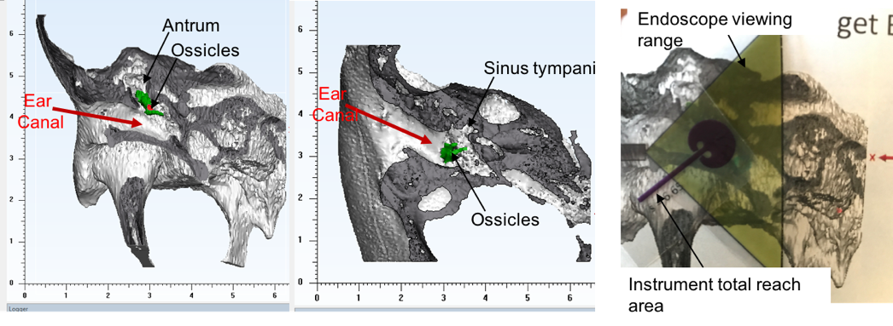

Figure 9: 3D virtual model of temporal bone anatomy used to identify structures for the new tool to reach. The ossicles (three hearing bones) are coloured in green. The ear canal is the channel indicated by the red arrow. The sinus tympani and antrum are shown and are the hard-to-reach areas where cholesteatoma is often found. The image on the right shows the 2D range experiment. The ‘instrument total reach area’ is a 2D area that describes the range of motion of the tip when it is articulated from totally bent to straight. The endoscope viewing range is shown in yellow, which highlights the area visualized by the 0o endoscope.

To determine the approximate, appropriate range of motion for the proposed tool to reach in difficult to reach areas within the middle ear during TEES, a simplified, modified approach, inspired by the Fichera et al. study was conducted. The range of arc length and radius of curvature needed to be identified. The PI provided 9 CT scans from patients with difficult TEES anatomy where bone had to be removed to access the cholesteatoma to remove it. The CT scans were segmented using Materialise Mimics and 3-Matic image segmentation software. 3D models of the patients’ temporal bone were rendered and within these, specific anatomy: the sinus tympani and antrum were identified, see Figure 8. The next step was to determine the range of arc lengths for the new tools, see Table 2. The radius of curvature is bound by the outer radius of the tube: minimum radius of curvature = 2 X tube OD.

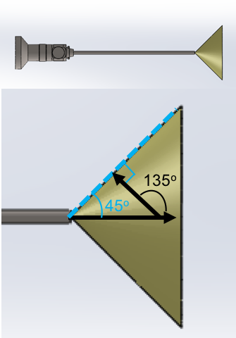The maximum arc length is approximately the distance between the endoscope at the medial end of the ear canal, where the middle ear begins, and the promontory which is a boney projection, see Figure 11. Dahm et al. reported the anatomical measurements on 60 cadaver specimens, and reported that the average distance between the promontory and tympanic spine is 7.48mm for all specimens and this distance does not change with age [27]. This is approximately the length of the middle ear and a longer instrument would not fit inside the space. The desired bending angle is 135o, which allows the instrument tip to access a region that is on the boundary of the 0o endoscope, see Figure 10. Using Matlab, 10 arc lengths were randomly generated to span the range 2.92-7.5mm and these were used to generate a 2D sketch of the workspace/reaching area of a joint with that arc length sweeping from radius of curvature 1.24 mm to straight. The 2D tool range of articulation sketch, 2D endoscope viewing angle and anatomy were printed and overlaid to determine the appropriate arc lengths to reach the targets, see Figure 8. A shorter arc length yields a stiffer tip, which is desirable for dissection and better control of the instrument. Since the anatomy was variable, the minimum and maximum arc length were both desirable as the minimum would allow for dissection with a stiffer tip and the maximum would allow for maximum reach. This determined the curvature of the tip in order to access hard-to-reach areas visualized by the endoscope. The next step was to test this in physical 3D printed models and add other functionalities to the prototype, which is discussed next.

Figure 11: 0o Endoscope viewing range. It shows that in order to reach the boundary of the viewing range, a tool tip would need to be oriented 135o from straight.

Table 2: *Radius of Curvature and Arc Length Range Calculations*

|  |  |  |
| --- | --- | --- |
|  | **Radius of Curvature (Rc)** | **Arc Length (s)** |
| Min | Rcmin = 2*Ro = **1.24mm**  Smin = minimum arc length  Ro = outer radius of NiTi tube | S = rθ  S = 1.24*3pi/4 = **2.92mm**  To achieve bending angle = 135deg. To reach the boundary of the 0deg endoscope field of view |
| Max | S=Rc*θ  Rc = s/θ = 7.5/(3*pi/4) = **3.18mm** | **7.5mm**: distance between promontory (bony boundary of middle ear) and tympanic spine* |

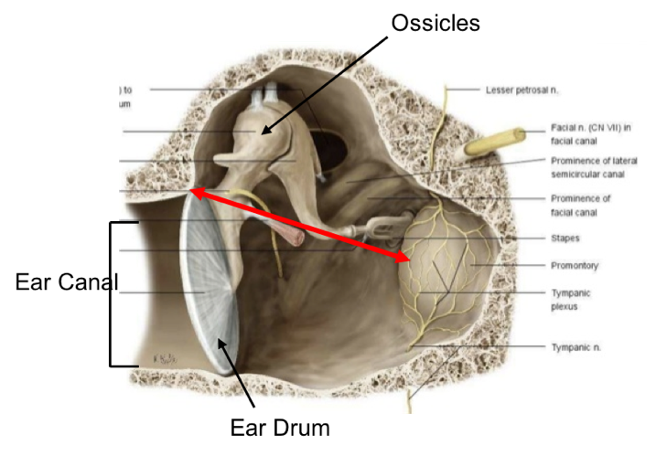

Figure 12: Image showing middle ear anatomy. The red arrow shows the approximate distance between the tympanic spine and the promontory [28].

## 3.1.3.2. Objective 2: Suction Instrument

This instrument incorporates the wrist, and is therefore steerable, with the added functionality of suction. Plastic tubing is attached to the shaft and runs along the handle of the instrument and terminates at a connector which is connected to a luer lock. The luer lock allows the suction instrument to be connected to the suction port in the operating room. The zoomed in section of Figure 12 shows that the cable exits the tubing and is accessible to be secured in the finger piece. The suction instrument is able to suction liquid. Further testing will compare the suction power with the 19 gauge sucker and Panetti instruments.

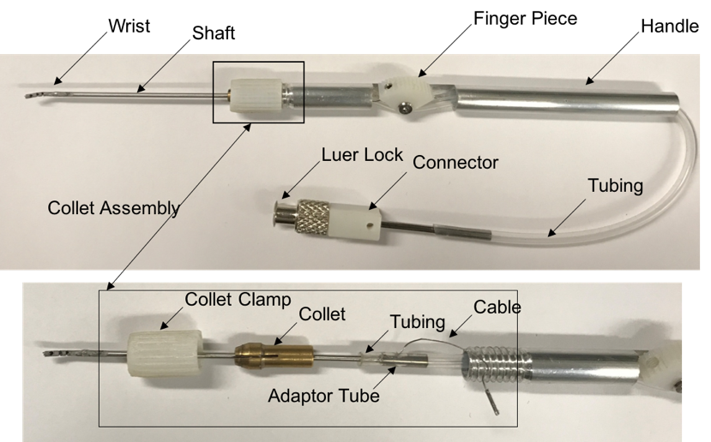

Figure 12: Outlines the components in the suction tool prototype.

## 3.1.3.3. Objective 3: Laser Fibre Instrument

This instrument is manufactured similar to the suction tool prototype but instead of the tubing running along the handle, it provides a channel for the laser fibre to be fed through to the tip.

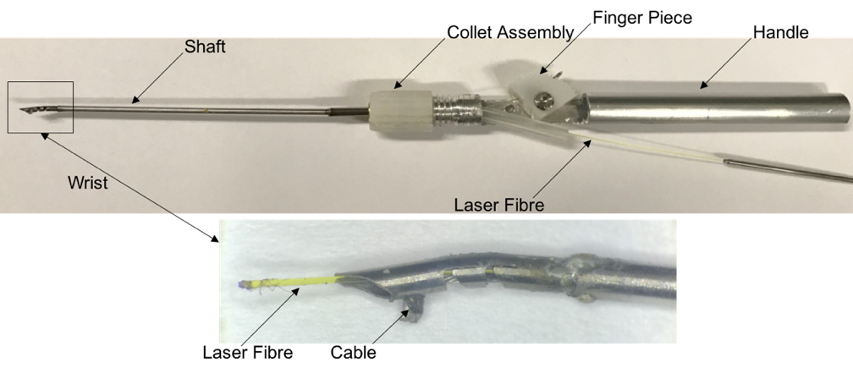

Figure 13: Outlines the components in the laser fibre tool prototype.

## 3.1.3.4. Objective 4: Dissection-Enabled Instrument Tip

Refer to Figure 14. The tip of the instrument was milled such that the tip shape would be able to dissect tissue. As the shape of the tip is a cylinder, similar to the Thomassin Dissector shaft which is commonly used by the PI for dissection, the tip was milled to a similar shape. Testing the instrument tip using a dissection test will be used to further inform this design.

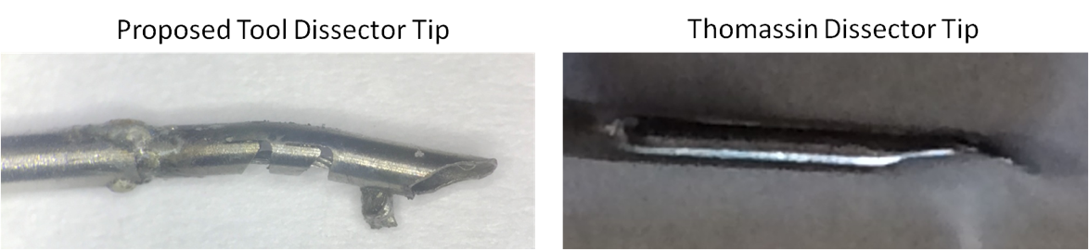

Figure 14: Shows a zoomed in view of the dissector tip, inspired by the Thomassin Dissector Tip.

## 

## 3.1.4. Testing Objective 1 – Reaching Structures Visualized by the Endoscope:

The reach of the instrument was tested using a 2.7mm 0o endoscope and 3D printed temporal bone models that were constructed from patient CT scans using Materialise Mimics and 3-Matic image segmentation software. Refer to Figure 15 for testing images. The endoscope was inserted alongside the instrument into the ear canal of the model, to simulate TEES and to evaluate if the tip was able to reach and dissect hard-to-reach structures. It was able to reach the sinus tympani and trace the antrum boundary. As well, the tip was stiff enough to dissect the boundary of the antrum, simulating dissection of cholesteatoma.

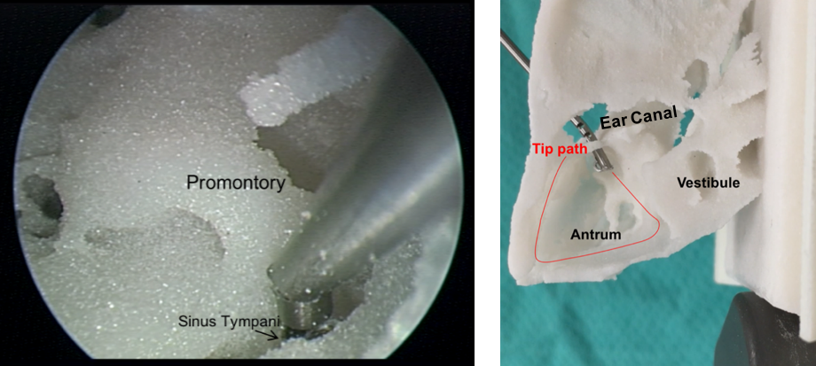**Figure 16:** **Left image: tool reaching the sinus tympani.** This is a model of the left temporal bone. The promontory is a landmark bone inside the middle ear, behind the ossicles. The sinus tympani is shown and is very difficult to reach into with standard, rigid tools to dissect and remove cholesteatoma. Often, the cholesteatoma is visualized in the sinus tympani with the endoscope but the tools cannot reach inside to extract it. This image shows, with an endoscope view, that the controllable, flexible instrument can reach into the sinus tympani. **Right image: tool reaching the antrum boundary.** This is a model of the left temporal bone. The model has been cropped so that the antrum is visible in this bird’s eye view. Cholesteatoma had eroded the ear canal in this patient like an atticoantrostomy, a hole in the ear canal where the instrument is coming through. Thus, the instrument is introduced through that opening and the tip can reach and dissect the boundary of the antrum.

Multiple iterations of the prototype were manufactured and tested. The controllable flexible instrument, see Figure 8, was presented at the 2nd World Congress for Endoscopic Ear Surgery in Bologna, Italy in April, 2017. It showed otologists the proof of concept that a controllable, flexible manually-operated instrument can reach structures visualized by the endoscope that are difficult to reach with conventional instruments.

Figure 12 and Figure 13 show the instruments that have incorporated suction, laser fibre and dissection at the tip and aim to be presented at the Sentac 2017 Annual Meeting on pediatric otolaryngology and will be submitted the IEEE Engineering in Medicine and Biology Conference, 2018.

# 4.0. Future Work

## 4.1. Validation Testing of the Instrument

The requirements in Table 1 will be tested to validate the tool for use during TEES. The functional requirements will be tested inside 3D printed models generated by the nine patient CT scans.

The tool will be manufactured for sterilizability, using medical grade materials for all parts. At this stage of the project, however, a proof of principle prototype has been constructed and does not comply by the necessary ISO 13485 standards for medical devices. Furthermore, the handle and finger piece will be developed in the future for ergonomic design and this design will be informed by user feedback.

## 4.1.1. User Feedback:

The goal of this testing is to gain user feedback to inform design changes to generate the next version of the instrument.

### Test 1: Target Reachability

Goal: quantify reachability. Temporal bone models will be 3D printed where the hard-to-reach areas, to be reached by the instrument tool tip will be coloured. Using an endoscope, the current tools (Panetti and Karl Storz sets) and the instrument prototypes will be tested inside the models. The number of targets reached by each tool will be tallied to determine which tool(s) have better reach. This will also inspire the next iteration of tool tip design.

### Test 2: User Feedback

Goal: assess user feedback during surgery. The methods of acquiring user feedback by Armstrong et al, Schneider et al. and Addis et al. will be used to validate the instrument prototype. Armstrong et al. tested a novel laryngoscope instrument stabilizer by asking surgeons to use it and rate the instrument functionality, stability, safety and utility on a survey [29]. The mean Likert scores of each question were presented [29]. Similarly, Schneider et al. tested robotic-assisted laparoscopic ultrasonography for hepatic surgery by asking 10 subjects to complete a questionnaire after performing specific task experiments, using the robotic tool and a handheld tool, the experience of participants was noted, and they were asked to comment on instrument functionality, comfort, ease of use and usefulness of the tool [30]. The scores were analyzed using a t-test for statistical differences [30]. Addis et al. outlined a testing protocol to compare a standard instrument and a prototype forceps and cutting instrument [31]. Six tasks were developed using a standard and literature and participants testing the tool were asked to comment on the tool’s performance; the frequency of specific comments, e.g. “this tool is helpful” were assessed [31].

Furthermore, another PhD. candidate from CIGITI is testing a similar instrument for neurosurgery using a user feedback survey, developed using literature and expert neurosurgeon input; their REB will be amended to conduct this validation study which has the same scope, objectives and outcomes, but for another surgical environment. The validation of the instrument prototypes will undergo a similar validation testing protocol. The user feedback survey, developed using the neurosurgery survey with expert otologist input (see Appendix A) will be used to obtain surgeon feedback on the following aspects of the tool: instrument form, operation, functionality (including using the instrument tip to bend and dissect mock cholesteatoma), performance, safety, functionality and comfort. The Likert Scale scores will be analyzed using non-parametric Kruskal Wallis statistics method and qualitative comments will be summarized in a journal paper.

Appendix A:

<<attach C:\Users\arushri swarup\Documents\GitHub\Grad-School\REB\TEES Instrument Testing Survey\ Survey - ENT Instrument 2017-08-25 AS>>

# 5. Timeline

Bibliography

[1] N. Nassif, M. Berlucchi, and L. O. R. de Zinis, “Tympanic membrane perforation in children: Endoscopic type I tympanoplasty, a newly technique, is it worthwhile?,” *Int. J. Pediatr. Otorhinolaryngol.*, vol. 79, no. 11, pp. 1860–1864, 2015.

[2] M. S. Cohen, L. D. Landegger, E. D. Kozin, and D. J. Lee, “Pediatric endoscopic ear surgery in clinical practice: Lessons learned and early outcomes,” *Laryngoscope*, p. n/a–n/a, 2015.

[3] H. Kanona, J. S. Virk, and A. Owa, “Endoscopic ear surgery: A case series and first United Kingdom experience.,” *World J. Clin. cases*, vol. 3, no. 3, pp. 310–7, 2015.

[4] M. Badr-el-dine, “Instrumentation and Technologies in Endoscopic Ear Surgery,” *Otolaryngol. Clin. NA*, vol. 46, no. 2, pp. 211–225, 2013.

[5] M. L. Bennett, D. Zhang, R. F. Labadie, and J. H. Noble, “Comparison of Middle Ear Visualization With Endoscopy and Microscopy,” *Otol. Neurotol.*, vol. 37, pp. 362–366, 2016.

[6] M. Tarabichi, “Endoscopic Middle Ear Surgery,” *Ann. Otol. Rhinol. Laryngol.*, vol. 108, no. 1, pp. 39–46, 1999.

[7] R. A. Chole, H. A. Brodie, and A. Jacob, “Surgery of the Mastoid and Petrosa,” *Ento Key Fastest Otolaryngology & Ophthalmology Insight Engine*, 2016. [Online]. Available: https://entokey.com/surgery-of-the-mastoid-and-petrosa/. [Accessed: 25-Sep-2017].

[8] IWGEES, “Instruments for Endoscopic Ear Surgery,” 2011. [Online]. Available: http://www.sinuscentro.com.br/iwgees/instruments.htm. [Accessed: 25-Sep-2017].

[9] K. O. Paulose, “Micro Ear Surgery in Jubilee Hospital Trivandrum, Kerala,India,” 2017. [Online]. Available: http://drpaulose.com/ear/ent-pediatric-children/micro-ear-surgery-in-jubilee-hospital-trivandrum-keralaindia. [Accessed: 25-Sep-2017].

[10] T. Mijovic and J. Lea, “Training and Education in Endoscopic Ear Surgery,” *Curr. Otorhinolaryngol. Rep.*, vol. 3, no. 4, pp. 193–199, 2015.

[11] C. Kuo and H. Wu, “Comparison of endoscopic and microscopic tympanoplasty,” *Eur. Arch. Oto-Rhino-Laryngology*, vol. 10, no. 1, pp. 1–6, 2017.

[12] Columbia University Medical Centre, “Endoscopic Ear Surgery,” 2016. [Online]. Available: http://entcolumbia.org/our-services/otology-neurotology/endoscopic-ear-surgery. [Accessed: 25-Sep-2017].

[13] M. Yong, T. Mijovic, and J. Lea, “Endoscopic ear surgery in Canada : a cross-sectional study,” *J. Otolaryngol. - Head Neck Surg.*, pp. 1–8, 2016.

[14] S. C. Prasad, A. Giannuzzi, E. A. Nahleh, G. De Donato, A. Russo, and M. Sanna, “Is endoscopic ear surgery an alternative to the modified Bondy technique for limited epitympanic cholesteatoma?,” *Eur. Arch. Oto-Rhino-Laryngology*, vol. 273, no. 9, pp. 2533–2540, 2016.

[15] A. L. James and B. C. Papsin, “Ten Top Considerations in Pediatric Tympanoplasty,” *Otolaryngol. -- Head Neck Surg.*, vol. 147, no. 6, pp. 992–998, 2012.

[16] A. L. James, “Endoscopic Middle Ear Surgery in Children.,” *Otolaryngol. Clin. North Am.*, vol. 46, no. 2, pp. 233–44, Apr. 2013.

[17] Spiggle and Theis, “Panetti Instrument Set,” 2017. [Online]. Available: http://www.spiggle-theis.com/en/products/otology/panetti-instrument-set. [Accessed: 03-Oct-2017].

[18] Grace Medical, “Endoscopic Instruments,” 2017. [Online]. Available: http://www.gracemedical.com/products/endoscopic-instruments/endoscopic-instruments/. [Accessed: 03-Oct-2017].

[19] Storz, “Instrument Set for Endoscopic Middle Ear Surgery,” *EndoWorld Karl Storz - Endoskope*. pp. 1–16, 2016.

[20] R. Yasin, B. P. O’Connell, H. Yu, J. B. Hunter, G. B. Wanna, A. Rivas, and N. Simaan, “Steerable Robot-assisted Micromanipulation in the Middle Ear,” *Otol. Neurotol.*, vol. 38, no. 2, pp. 290–295, 2017.

[21] L. Fichera, N. P. Dillon, D. Zhang, I. S. Godage, M. A. Siebold, B. I. Hartley, J. H. Noble, P. T. Russell, R. F. Labadie, and R. J. Webster, “Through the Eustachian Tube and Beyond: A New Miniature Robotic Endoscope to See Into the Middle Ear,” *IEEE Robot. Autom. Lett.*, vol. 2, no. 3, pp. 1488–1494, 2017.

[22] H. J. Marcus, T. P. Cundy, A. Hughes-hallett, Z. Yang, A. Darzi, D. Nandi, and D. Phil, “Europe PMC Funders Group Endoscopic and Keyhole Endoscope-assisted Neurosurgical Approaches : A Qualitative Survey on Technical Challenges and Technological Solutions,” vol. 28, no. 5, pp. 606–610, 2015.

[23] Salient Medical, “Vitreoretianal Laser Probes,” 2017. [Online]. Available: http://salientmed.com/solution/endoprobe-handpieces/. [Accessed: 03-Oct-2017].

[24] M. J. McGowan, C. R. Hurst, H. M. Lambert, and C. F. Lumpkin, “US7766904.pdf.” p. 14, 2010.

[25] Ã. A. L. James, Ã. S. Cushing, and Ã. B. C. Papsin, “Residual Cholesteatoma After Endoscope-guided Surgery in Children,” pp. 196–201, 2015.

[26] T. Ito, T. Kubota, T. Watanabe, K. Futai, T. Furukawa, and S. Kakehata, “Transcanal endoscopic ear surgery for pediatric population with a narrow external auditory canal,” *Int. J. Pediatr. Otorhinolaryngol.*, vol. 79, no. 12, pp. 2265–2269, 2015.

[27] M. C. Dahm, R. K. Shepherd, and G. M. Clark, “The Postnatal Growth of the Temporal Bone and its Implications for Cochlear Implantation in Children,” 1993.

[28] R. M. Sherif, “The Middle Ear Cleft,” 2015. [Online]. Available: https://www.slideshare.net/dr_razal/anatomy-of-middle-ear-54308120. [Accessed: 07-Oct-2017].

[29] W. B. Armstrong, A. M. Karamzadeh, R. L. Crumley, T. F. Kelley, R. P. Jackson, and B. J. F. Wong, “A novel laryngoscope instrument stabilizer for operative microlaryngoscopy,” *Otolaryngol. - Head Neck Surg.*, vol. 132, no. 3, pp. 471–477, 2005.

[30] C. M. Schneider, P. D. Peng, R. H. Taylor, G. W. Dachs, C. J. Hasser, S. P. Dimaio, and M. A. Choti, “Robot-assisted laparoscopic ultrasonography for hepatic surgery,” *Surgery*, vol. 151, no. 5, pp. 756–762, 2012.

[31] M. Addis, M. Aguirre, M. Frecker, R. Haluck, A. Matthew, E. Pauli, and J. Gopal, “Development of Tasks and Evaluation of a Prototype Forceps for NOTES,” *JSLS J. Soc. Laparoendosc. Surg.*, vol. 16, no. 1, pp. 95–104, 2012.

[32] M. Tarabichi, D. Marchioni, L. Presutti, D. Pothier, and J. F. Nogueira, “Endoscopic Transcanal Ear Anatomy and Dissection Manual,” Dubai,UAE; Modena, Italy; Toronto, Canada; Fortaleza, Brazil, 2011.

[33] N. Pollak, R. Azadarmaki, and S. Ahmad, “Endoscopic Treatment of Middle Ear Myoclonus with Stapedius and Tensor Tympani Section : A New Minimally-Invasive ... Endoscopic Treatment of Middle Ear Myoclonus with Stapedius and Tensor Tympani Section : A New Minimally-Invasive Approach,” no. January, 2016.

[34] J. Flávio, N. Júnior, and D. N. Cruz, “Ear Endoscopic Surgery : Dissection of the Middle Ear,” pp. 421–425, 2009.